Here is a look at the data sets for the Lan Exam
The Story

You've been hired as the data analyst for a series of studies exploring the effectiveness of "Treatment X" (TxX) which is designed to ameliorate depressive symptomology. For all studies the outcome variable (DV) is the Mental Health Index (MHI -- higher scores are "better"). Analyze the data from each study and answer the questions that are asked. Do not provide a complete “results section” for each analysis, just answer the questions!!

Study 1
Study #1 (10 points)
Moderately depressed adult participants were randomly assigned to receive either weekly sessions of the new TxX therapy or be in a no-treatment control. Four months later, depression was measures from all participants using the MHI.
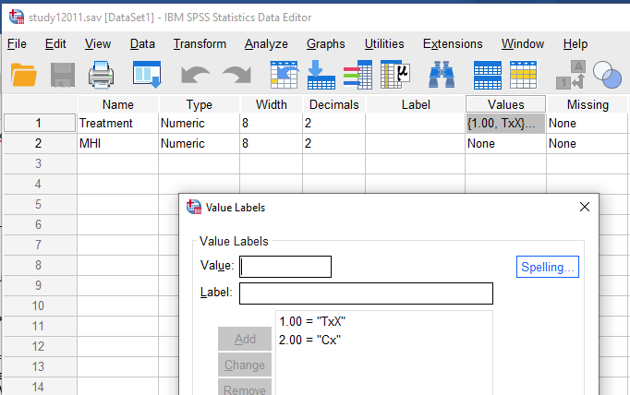

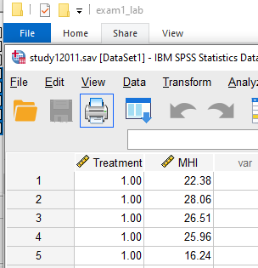

Study 2

Study #2 (20 points)
To compare TxX to other available treatments of depression, moderately depressed adolescent participants were randomly assigned to receive twice-weekly sessions of either TxX, standard Cognitive-Behavioral Therapy (CBT), Cogno-Affective Therapy (CAT), or Peer-Based Counseling (PBC). After 2 months of treatment, all participants were assessed for depression using the MHI.
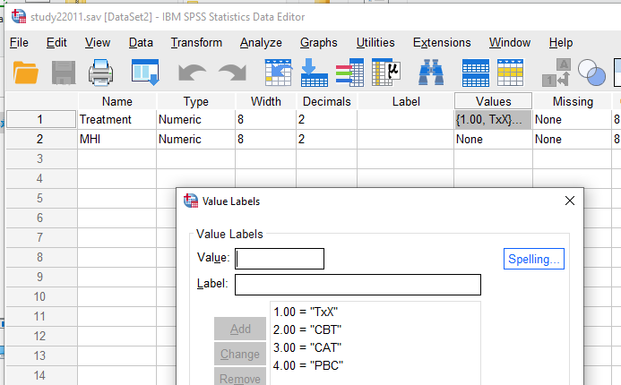

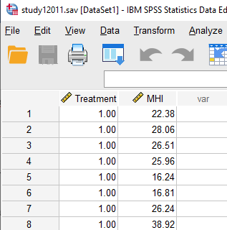

Study 3
Study #3 (20 points)
The next study was designed to examine the time-course of treatment response of moderately depressed adult patients to TxX. Each patient underwent four months of treatment with TxX and completed the MHI before the first treatment session and at the end of each month
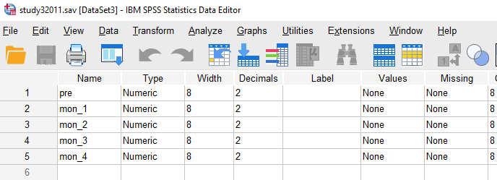

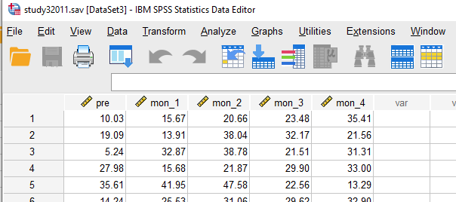

Study 4
Study #4 (25 points)
The next study was designed to consider whether TxX worked equally effectively for patients with differing amounts of initial depression. Adult patients were identified who were "moderately" or "severely" depressed. Members of each group were randomly assigned to receive 4 months of TxX, or receive no treatment. MHI data were collected after 4 months of treatment.
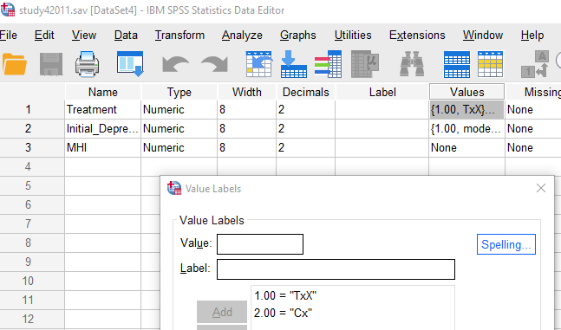 | 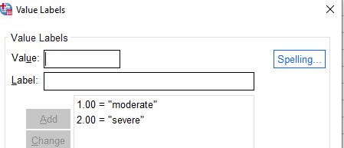

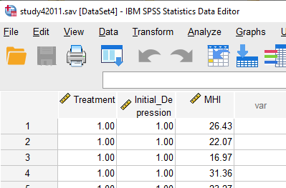

Study 5
Study #5 (25 points)
This study was designed to compare the time-course of TxX and CBT. Adolescent patients were randomly assigned to the type of treatment they would received. MHI data were collected at 4 and again at 8 months after treatment
