Connect to psyc-statlab remote Desktop

Date: 7/29/2022
Name: Saul Schimek
Length of time to complete: 5-15 minutes
Difficulty: Intermediary

Steps to download and Connect to VPN from personal device
- Connect to VPN (Global protect) using their UNL(Canvas) Login.
- Instructions to downloading vpn, connecting and disconnecting
- Downloading VPN Client
- Navigate to https://nu-vpn.nebraska.edu
- Sign in with your NUID and password.
- You should be prompted for DUO 2-factor by whatever method you have chosen.
- Once signed in, download the client by clicking “Global Protect Agent” on the main page and choosing the version that matches your Operating System. If you have windows, You should have Window 64 Bit, so install the 2nd one listed. If you Mac/Apple then you will need to install the Mac 32/64 bit Global Protect Agent.
- Install the GlobalProtect Agent by opening the downloaded file named GlobalProtect, and following the prompts within the installer (Once installed, there will be a Globe icon in the Windows taskbar, at the bottom right of the screen, for quick access).
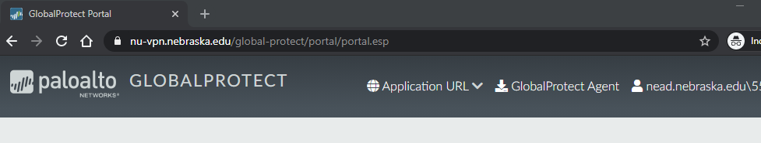
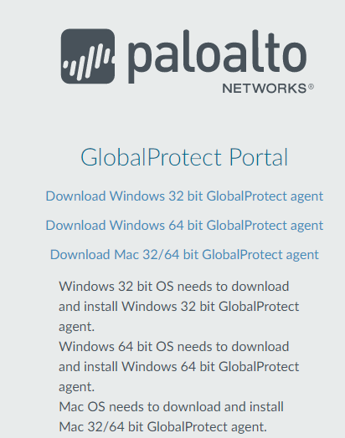
Running the VPN Client
- From the Start Menu, open the GlobalProtect App, or click on the GlobalProtect icon on the Taskbar.
- Enter the portal address of nu-vpn.nebraska.edu
- Click the Connect button.
- When prompted, sign in with your NUID and password (You should then be prompted for DUO 2-factor by whatever method you have chosen).
- Once connected, you should see the GlobalProtect icon in the Taskbar with a small shield icon indicating the connection.
- To view your VPN settings, click the icon in the Taskbar, and then find the settings menu by clicking on the three horizontal lines in the upper right. From there, you can view tabs that show your connection details.

Connect to remote desktop on PC
- To access Remote Desktop Client, Click on the start button and start typing Remote. Select the remote desktop connection from the search results to open the program.
- Type in PSYC-Statlab, and then click on Connect
- It will then prompt you for your username and password. Select more choices and then use a different account. Use your canvas email address and password.
- If prompted with a certificate warning about the remote computer identity, you can select Don’t ask me again for connections to this computer, and click the Yes button.
- If you get any other error message, please send email to artscisupport@unl.edu. Please include screenshot of error-- along with you NUID, NU log in information, as well as class that you are in.
- You should now see a desktop and any open programs and files running on it, as well as be able to access any other University resources. MPLUS, HLM, STATA, and SPSS icon should be listed on the desktop.
- When you are finished working remotely, remember to disconnect your remote session, by clicking the X.
- If the remote connection bar is not visible at the top of your screen, move the mouse all the way to the top center of your screen and it should appear.

Exiting the VPN Client
- When you no longer wish to be connected, click on the Global Protect icon on the Taskbar, and click Disconnect.

In Burnett 230
- On lab machine, log in as usually done with UNL Credentials.
- On the desktop should be a remote desktop icon that says psyc-statlab.
- Click on Connect. It will prompt you to login.
- Use your UNL credentials and password.
- It should then display the psyc-statlab remote desktop, and you can use software as usual.

